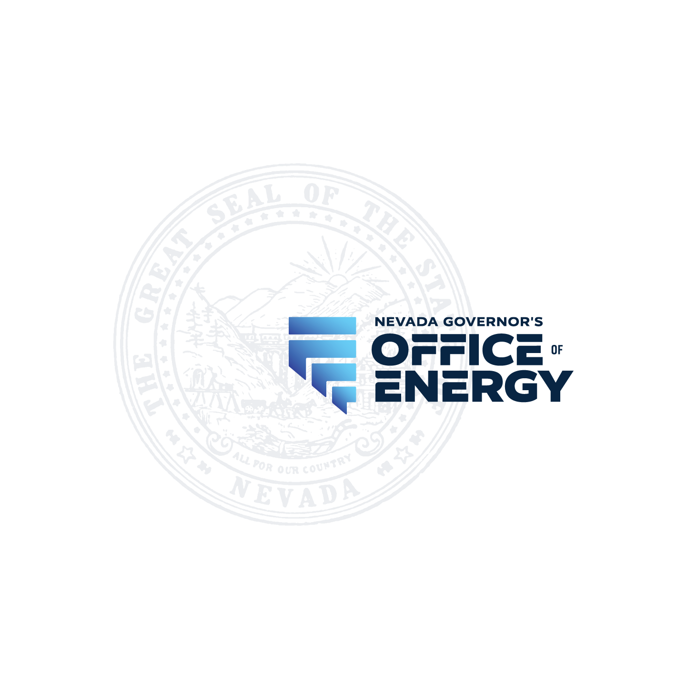
Dwayne McClinton
Director
Joe Lombardo
Governor
600 E William St #200
Carson City, NV 89701

MINUTES
Of the Renewable Energy Tax Abatement Hearing of the GOVERNOR'S OFFICE OF ENERGY

AFN 25-1015SPV
Libra Solar LLC

The Governor's Office of Energy held a public meeting on December 11, 2025, beginning at 9:00 AM at the following location:

Via Videoconference – Microsoft Teams Meeting ID: 217 782 357 148 32
Passcode: 8PS7cC2e

Via Phone:
Conference Call Number: 775-321-6111 Phone Conference ID: 745926688#

Present at the hearing:
Dwayne McClinton, Director of the Governor’s Office of Energy
Rachelle Doubinkine, Energy Program Manager, Governor’s Office of Energy Marjorie Hilke, Management Analyst III, Governor’s Office of Energy
Nicole Ting, Deputy Attorney General, State of Nevada Attorney General Office
John Schillo, Department of Taxation
Joshua Hicks, Partner at McDonald Carano
Kathryn Arbeit, Principal of Potrero Consulting, LLC
Brian – Public Call In
Anonymous Call In

- Call to order: The meeting was called to order at 9:04 AM by Director Dwayne McClinton. The Director stated that this was a hearing on the merits of the application for partial abatement of property taxes and sales and use taxes originally filed by Libra Solar LLC on October 15, 2025. Application filing number 25-1015SPV. This is an application for a 700 MW solar facility located in Mineral County, NV.

- Public comment and discussion (1st period): The Director asked if anyone from the public sought to make a comment on the matter. There was no public comment.

- Presentation of Evidence and Testimony: The Director submitted Exhibits A-F, a packet of documents consisting of: Exhibit A - Notice of Public Hearing, dated November 18, 2025; Exhibit B - A redacted application as filed with the Governor's Office of Energy on October 15, 2025; Exhibit C – Fiscal Impact of the partial abatement of property tax as required by NRS 701A.375-1 by the Nevada Department of Taxation, received on October 27, 2025; Exhibit D - Fiscal Impact of the partial abatement of sales and use tax as required by NRS 701A.375-1 by the Nevada Department of Taxation, received on November 6, 2025; Exhibit E - Fiscal Impact of the partial abatement as provided by the Governor’s Finance Office, required by NRS 701A.375-1, received on October 27, 2025; Exhibit F – Pre-filed testimony of Kathryn Arbeit.

The Director admitted Exhibits A-F into evidence in this matter.

The Director asked whether the applicant had any additional information they would like to add. There was no additional information.

The Director asked if there was any additional information to be submitted on this matter. There was no additional information submitted.

The Director asked whether anyone would like to make a closing statement. Joshua Hicks with McDonald Carano wanted to say thank you to the director and staff for helping them through the application process.

The Director closed the evidentiary portion of the hearing and thanked everyone for their testimony.

- The Director stated his findings and conclusions based upon the substantial, reliable, and credible evidence presented in the exhibits and testimony.

As to NRS 701A.360 (1), the Director found that the applicant intends to locate within this State a facility for the generation of solar energy, thus meeting the intent of the statute.

As to NRS 701A.360(2), the Director found that the facility is not owned, operated, leased, or controlled by a government agency, thus meeting the requirement of the statute.

The Director found that NRS 701A.365(1)(a)(1) has been met by this renewable energy project, as the facility is expected to continue in operation in this State for a period of at least 10 years and is expected to continue to meet the eligibility requirements for the abatement.
As to NRS 701A.365(1)(b), the applicant has provided information supporting testimony that all the necessary state and local permits and licenses to construct and operate will be received, thus meeting the requirement of the statute.

As to NRS 701A.365(1)(c), the applicant has provided testimony that no funding for facility is or will be provided by any governmental entity in this State for the acquisition, design, or construction of the facility or for the acquisition of any land therefore, thus meeting the requirement of the statute.

As to NRS 701A.365(1)(e)(1), the application states that the construction of the facility will employ 650 full-time employees during the second quarter of construction of which at least 50% will be Nevada residents.

As to NRS 701A.365(1)(e)(2), the Director found that the total capital investment in the facility is estimated to be approximately $2,500,000,000.00 thus exceeding the $3,000,000.00 capital investment required by the statute.

As to NRS 701A.365(1)(e)(3), the Director found that this statute is met as the application states that the average hourly wage paid by the facility to its operational employees, excluding management and administrative employees, will be approximately $34.73, which is at least 110% of the average statewide hourly wage set by DETR of $31.57.

As to NRS 701A.365 (1)(e)(4), the Director found that this statute is met as the application states that the average hourly wage that will be paid by the facility to all of its construction employees working on the facility, excluding management and administrative employees, will be approximately $55.25, which is at least 175% of the average statewide hourly wage set by DETR of $31.57.

As to NRS 701A.365(1)(e)(4)(I) and (II), the application states that the health insurance provided to the construction employees on the facility allows for the coverage of the dependents of the employees and will meet or exceed the standards established by the Director, thus meeting the requirement of the statute.

As to NRS 701A.365(1)(f), the Director found that the benefits that will result to this State from the employment by the facility of the residents of this State and from capital investments by the facility in this State exceeds the loss of tax revenue that will result from the abatement, thus meeting the requirement of the statute.

The Director found that the financial benefits to the state exceeded the abated amounts and provided each figure. The total benefits to the state of Nevada are $2,551,074,296.00 and the total abatement is $241,656,511.48.

The Director found NRS 701A.365(1)(g) to be met as the facility is consistent with the State Plan for Economic Development developed by the Executive Director of the Office of Economic Development pursuant to subsection 2 of NRS 231.053.
As to NRS 701A.370(1)(a)(3), The Director found that the partial abatement of property tax did not apply during a time in which the facility was receiving an abatement for the same, other than any partial abatement provided pursuant to NRS 361.4722.

As to NRS 701A.370(1)(b)(1)(III), The Director found that the abatement will not apply during any period in which the facility was receiving another abatement or exemption from local sales and use taxes, thus meeting the requirement of the statute.

- Approval of Application. The Director approved the application for the partial abatement of property taxes and sales and use taxes. The Director explained that after today’s hearing, he will produce a written Findings of Fact, Conclusions of Law, and Order. Once the Order is issued, the Director or his representative, representatives from the Nevada Department of Taxation, and appropriate representatives of Libra Solar LLC may meet to go over the terms and conditions of the Abatement Agreement and after that meeting, we will execute the Abatement Agreement.

The Director stated that as a reminder, pursuant to NRS 701A.380, a partial abatement approved by the Director will terminate upon any determination by the Director that the facility has ceased to meet any eligibility requirements for the abatement.

- Public comment and discussion (2nd period): The Director asked if anyone had any public comment to which there was no response.

- Adjournment: 9:17 AM.

